FRANKFORT GERMANY – CONF NOV 2018:
VIDEOS: http://conference2018.monetative.de/videos/
Click on the image for details about the speaker.
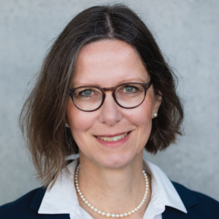

Dr. Katrin Assenmacher
Katrin Assenmacher is head of the Monetary Policy Strategy Division at the European Central Bank (ECB) since November 2016. From 2010 to 2016 she led the Monetary Policy Analysis unit at the Swiss National Bank (SNB). Her professional interests lie in the areas of monetary policy and time-series econometrics. She published several articles in international academic journals on modelling the role of money in the inflation process, analysing business cycle indices and estimating central bank reaction functions.
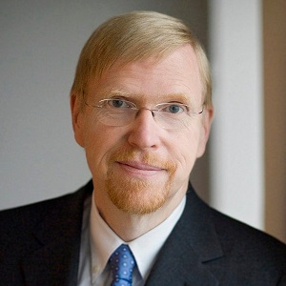

Prof. Dr. Thomas Mayer
Thomas Mayer is the founding director of the Flossbach von Storch Research Institute. From 2002 to 2009, he was Chief European Economist and Co-head of global Economics at Deutsche Bank in London and from 2010 to 2012 Chief Economist of the Deutsche Bank Group. His previous professional career includes Goldman Sachs (1991 to 2002), the International Monetary Fund (IMF) (1983 to 1990) and the Institute for the World Economy in Kiel (1978 to 1982). In 2015, he was appointed honorary professor by University Witten/Herdecke. Since 2002, he holds the title Chartered Financial Analyst.
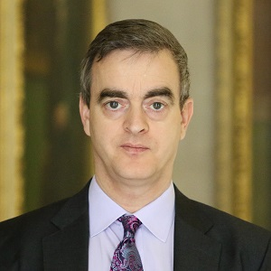

Dr. Michael Kumhof
Michael Kumhof is Senior Research Advisor in the Research Hub of the Bank of England. Before that, he was Deputy Division Chief, at the Modeling Division in the Research Department at the International Monetary Fund (IMF) (2004 to 2015). Kumhof was responsible for developing the Global Integrated Monetary and Fiscal Model of the IMF which is used at several central banks, for IMF policy and scenario analyses, for the World Economic Outlook, and for G20 work. Before that, he was Assistant Professor at Stanford University (1998 to 2004). His research focuses on the role of banks in the economy and on different monetary systems.
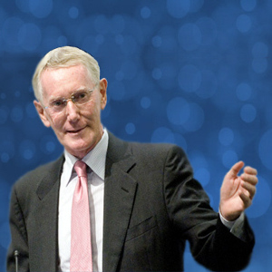

Dr. William White
William R. White is the former chairman of the Economic and Development Review Committee at the OECD. He was a member of the Issing Committee, advising the German chancellor on G-20 issues. Before that, he was Economic Adviser and Head of the Monetary and Economic Department at the Bank for international Settlements (BIS) (1995 to 2002). In 1969, his career started at the Bank of England. He joined the Bank of Canada in 1972 where he was made Chief of the Research Department, Adviser to the Governor and finally in 1988 Deputy Governor. He predicted the financial crisis of 2007 to 2010 before the 2007's subprime meltdown hit.
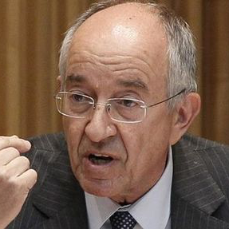

Miguel Á. F. Ordóñez
Miguel Fernández Ordóñez was the governor of the Spanish Central Bank and member of the Governing Council of the ECB from 2006 to 2012. Before this position, he was among others, Secretary of State for the Spanish Ministry of Economy and Secretary of State for the Ministry of Finance. He also held positions as Chairman of a Securities firm and board member of a big commercial bank. He was also member of the IMF Board, President of the Competition Court, President of the National Electricity Commission and lecturer at the Universidad Complutense in Madrid
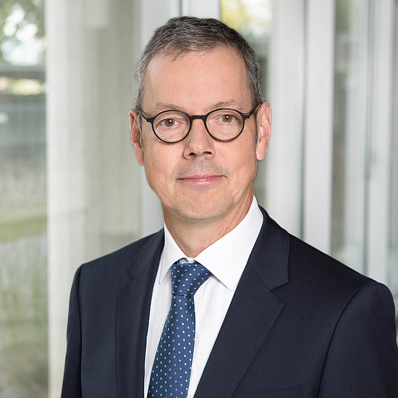

Prof. Dr. Peter Bofinger
Peter Bofinger is the longest serving member of the German Council of Economic Experts which regularly writes reports to the German government about the overall Economic development. Before becoming professor of economics at University of Würzburg in 1992, he was an economist at the Bundesbank (1985 to 1990). Already from 1978 to 1981 he was member of the scientific research team for the German Council of Economic Experts. Bofinger wrote his doctorate thesis about Currency Competition and the vision of Friedrich August von Hayek.

Conference Agenda
The Conference aims at debating the current debt-based money system and two major reforms in two parallel tracks and three sessions.

Click on the title of a talk to access the conference material (presentation, video, paper, etc.).

Time

Audimax

Lecture room
09:30-09:45
Klaus Karwat, Manuel Klein, Lino Zedies: Welcome, Introduction
09:45-10:15

Keynote: Banks Are Not Intermediaries of Loanable Funds - Facts, Theory and Evidence by Dr. Michael Kumhof
10:20-10:50

Keynote: The ECB’s monetary policy: Mandate, strategy and implementation by Dr. Katrin Assenmacher
10:55-12:35
Session:
Current money System
- Prof. Dr. Steve Keen: Why we Regularly Witness Financial Debt Crises due to Asset Price Inflation
- Dr. Michael Kumhof: Central Bank Digital Currencies – Benefits versus Costs
- Dr. Carl A. Claussen: Insights into the Riksbank e-krona project
- Jonathan McMillan: The rise of shadow banking: money creation in the digital age
- Dr. Norbert Häring: Brave New Money – PayPal, WeChat, Amazon Go – A totalitarian world currency in the making
- Stefan Möllenkamp: A bit(coin) out of control – The legal nature of cash, deposit money and cryptocurrencies
12:40-13:10

Keynote: Economic Outlook and The Need for Monetary Reform by Dr. William White
13:10-14:15
Lunch
14:15-14:45

Keynote: CBDC-Banking-Liberalization by Miguel Á. F. Ordóñez
14:50-16:30
Session:
Vollgeld
Sovereign Money
- Prof. Dr. Joseph Huber: Design principles for a Central Bank Digital Currency
- Prof. Dr. Ole Bjerg: CBDC in line with the Vollgeld approach?
- Dr. E. Dawnay / M. Degiacomi: Lessons learnt after the Swiss Referendum on Sovereign Money
- Prof. Dr. Laurence J. Kotlikoff: The Big Con – Reassessing the “Great” Recession and its “Fix”
- Edgar Wortmann: Evolution of Money in the Digital Age
- Manuel Klein: Vollgeld 101 – How does it work and what can it do?
16:35-17:05

Keynote: How can the Euro survive? Could money reform be a solution? by Prof. Dr. Thomas Mayer
17:05-17:20
Coffee break
17:20-17:50

Keynote: Digitalization of Money and currency competition by Prof. Dr. Peter Bofinger
17:55-19:00
Session:
Cryptocurrencies
- Søren Peter Nielsen: The Dai Credit System, A new infrastructure for financial applications on the Blockchain
- Dominik Schiener: IOTAs Vision of an Open and Decentralized Financial System
- Prof. Dr. Phillip Sandner: Blockchain, Bitcoin, Crypto Assets and ICOs: Emergence of a New Asset Class
- Veronika Kütt: Bitcoin 101 – How does it work, what can it do?
- Max Rangeley: Blockchain, The Austrian School and Monetary Reform
19:00-19:15
Break
19:15-20:00

Panel Discussion with:
- Dr. Gerhard Schick: Spokesman on financial policy of the German green party
- Dr. Cyrus de la Rubia: Chief Economist, HSH Nordbank
- Dr. Carl Christoph Hedrich: Senior Research Manager, Commerzbank
- Prof. Dr. Dr. Helge Peukert: Professor of pluralist Economics, Siegen University
- Ralph Bärligea: Banking Consultant, Bearing Point
- Marc Friedrich, Bestselling author
20:00-20:15
Closing Address, Get together

