PERFORMANCE ARRANGEMENT
FRIDAY, JUNE 16, 2017
BEACON PROGRAM – 154 WEST 93RD PUBLIC SCHOOL

* Yaya begins: "bom bom bom bam bom bom bom boom...'Zao-ou-lee' "

1. ZAOULY
* Sisters drumming (one time)
| /|\ | | | |
\|/ | \|/ \|/ \|/ \|/
T CCC T CCC T CCC B B B
T CCC T CCC T CCC B B B
T CCC T CCC T CCC

| | | | | |
\|/ \|/ \|/ \|/ \|/ \|/
T CCC CCC T CCC CCC
T CCC T CCC T CCC Flam Flam

2. SUNU
* Yaya queue (begin): "bum bu-bu bu-bu bu bum...'I will' "
* Sisters break: "I will not let you take my job (JOY, DRUMS, ETC.) away from me"
T-T T T T T T T T T T T FL FL
* Sisters drumming - sunu rhythm
Part 1: Sue, Diana, Barbara, Karen
Part 2: Dee Marta Paula
Part 1
T T T T T CK T T T CK
Part 2 (triplets)
CK T T CK CK Base CK T T CK CK Base

3. LAMBA
* Yaya queue "paula paula poola poola paula paula 'I' "
C C C C T T T T C C C C C
* Sisters break lamba break
“I love to sing even though it takes my breathe away I don’t care”
1 12 3 12 3 12 12 12 12 3 1 2
T TT T TT T TT TT TT TT T C C
* Yaya intro "Let's go now" (3 beats)
* Sisters drumming lamba rhythm
Part 1: Sue, Diana, Barbara, Karen
Part 2: Dee Marta Paula
LAMBA Part 1 Version 1
12 3 1 2 1 2 3 1 2 1 2 3 1 2 1 2 3 x x
TTC CC TTC CC TTC CC TTC C C
LAMBA Part 1 Version 2
12 3 1 2 1 2 3 1 2 1 2 3 1 2 1 2 3 x x
CCC TT CCC TT CCC TT CCC T T

4. KUKU
* Yaya queue (begin) "bam bam bam / beem beem beem / ba-ba 'ONE' "
* Sisters intro
| | | |
\|/ \|/ \|/ \|/

B tt pause B tt pause
B tt B tt B tt B tt
C t t C t C t t t
CCCC CCCC t t C C C
* Sisters drumming kuku rhythm
Part 1: Sue, Diana, Barbara, Karen
Part 2: Dee Marta Paula
* Yaya queue (end) "bam bam bam / beem beem beem / ba-ba 'ONE' "
* Sisters break (repeat)
| | | |
\|/ \|/ \|/ \|/

B tt pause B tt pause
B tt B tt B tt B tt
C t t C t C t t t
CCCC CCCC t t C C C

“FUNGA” (YahYah sings funga)
Sisters come in and join him after initial singing: funga Alafia, ashe ashe
funga Alafia, ashe ashe (2 times)
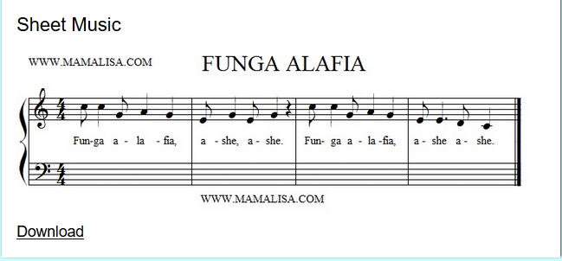
5. FUNGA
* Sisters's drumming funga rhythm
Part 1: Sue, Diana, Barbara, Karen
Part 2: Dee Marta Paula

YAHYAH ASKS 5 KIDS TO COME UP AND JOIN US ON DRUMS

6. Bolowee
/ / / /
tck ck ck ck ck bb
ttb ttb ttb ttb
tttt BtB ckBck BckB

7. Yaya calls out ( ‘kindergarden endings’ – in between each call Yaya says some jazzy notes ‘ BA BA BOO BOO YA YA YA)

#1 ‘BEAT THE DRUM’ B B B B B B B B B B B B B (13 TIMES) 13
‘BEAT THE DRUM’ B B B B B B B B B B B B B (13 TIMES) 13
‘BEAT THE DRUM’ B B B B B B B B B B B (11 TIMES) 11

#2 ‘2 ROWS’ TTTTT TTTTT (2 rolls fast) 5 + 5
‘2 ROWS’ TTTTT TTTTT (2 rolls fast) 5 + 5

#3 ‘BIG BANG’ B

#4 ‘2 BEATS’ t t
‘2 BEATS’ t t

#5 ‘QUICK ROLL’ TTTT TTTT TTTT T (fast) 13

YAHYAH GETS KIDS AND DEE UP DANCING
8. FINAL RTHYMS
Caliente
| | | |
TTTTT T B T B T

Timate | | | |
ck B-B-B ck B-B-B ck B-B-B T-T-T-T

9. CONTINUOUS ROLL TO END

