WE NEED PUBLIC MONEY…
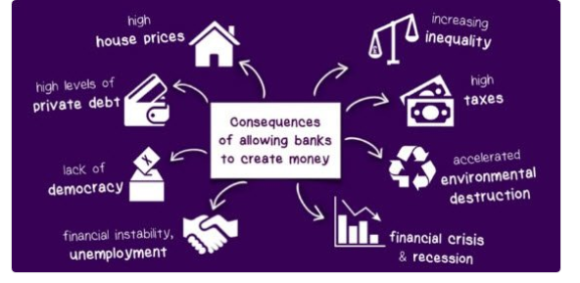
NOT PRIVATE BANKMONEY
COME LEARN ABOUT OUR MONETARY SYSTEM….
Exploring and Debating Monetary Policy Thurs 9:00 -- 10:15am—Blegen 120
Money and Democracy Thurs 10:30 -- 11:45am—Blegen 120
Money, Schooling, and Educators Thurs 2:30 -- 3:45pm—Blegen 140
The New Abolitionism: Monetary Reform Fri 10:30 -- 11:45am—Blegen 125
Climate Change and Money Fri 2:30 -- 3:45pm—Blegen 120

AMERICAN MONETARY INSTITUTE (AMI)
AMI ~ Phone: 224-805-2200 ~ Email: ami@taconic.net~ Web: www.monetary.org

